### Project - App(Cross Platform) for Examination

To Create an app for the conduct of examination in a proctored way.

First of all I would like to mention that we use **“ANDROID STUDIO”** that is one of the **“Best Free Open Source”** to create our **“Android Application”**

We have tried our best to add all the necessary things which is necessary to

Create app more **“User Friendly”.**

We added these things to Our Application :-

#### **Features**

Following Features Need to be implemented and provided

* Authentication system for making student login using LDAP by taking the following permissions from the user.

1. After accepting the terms and conditions user will not be able to use any application other than this app
2. He/She may not be able to close, minimize or change the size of window screen
3. Only WiFi and mobile data can be turned on, no other options such as Bluetooth etc can be turned on.
4. Calls and Notifications will be blocked.

* After login the user will be directed to the main page where exam can be conductes.
* Only the the services provided by exam brach will appear on the screen of device such as question papers, calcualtors, log tables, etc
* A portal for teacher for uploading question papers and to provide other tools required for exam such as calculator.

Now let me tell about How we **Create this application in 48hrs**.

* 1. Authentication system for making student login
* I have added ***google sign in Integration*** for the Secure Login :-

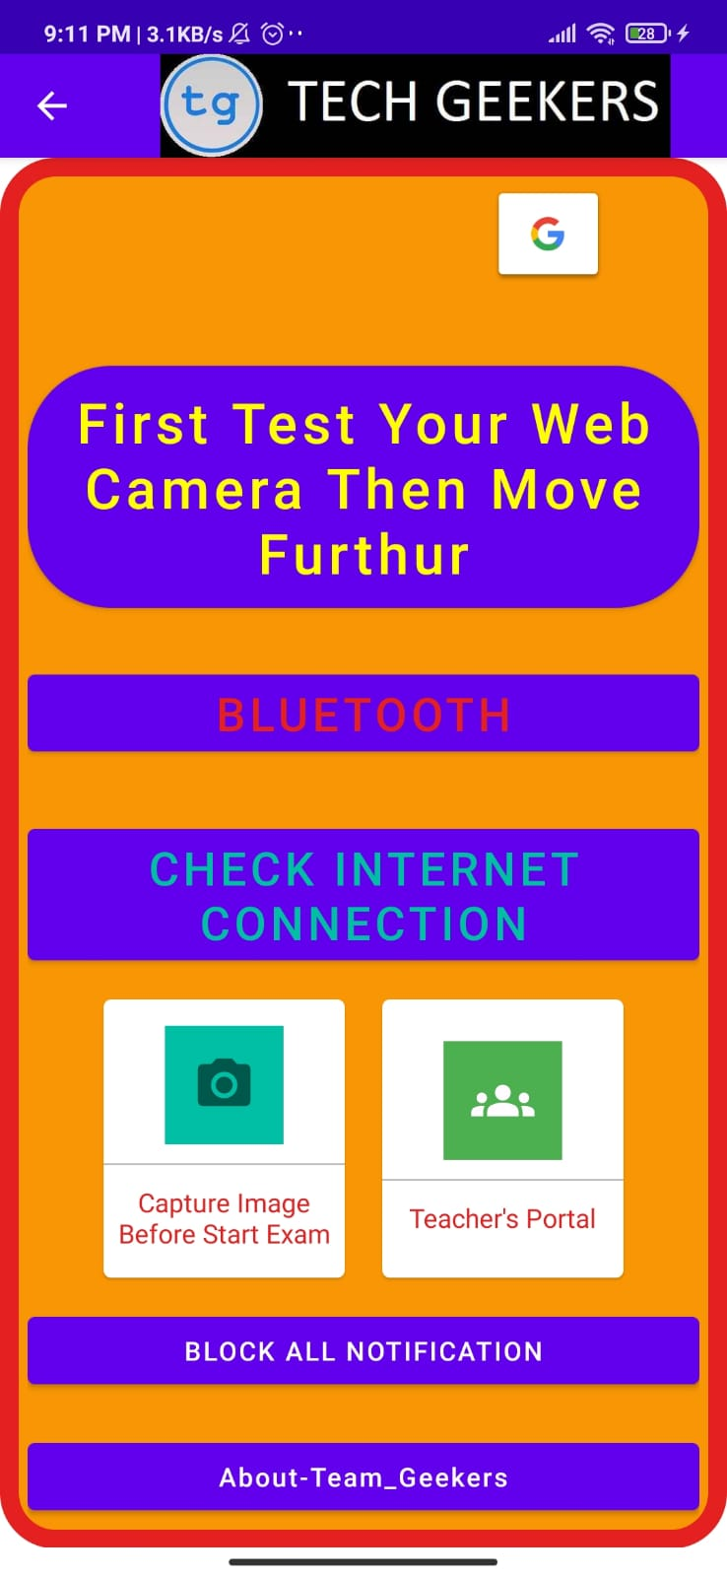THIS IS OUR **APPLICATION UI DESIGN**

At the top of the App Team name is mentioned that is TECH_GEEKERS

Now coding Part For this INTERFACE which covers

1. google sign in

2. first test your web cam then move further

3. Bluetooth checking button

4. check internet access or check it is off or on

5. two card view buttons which consist of CAPTURE IMAGE before start of the Examination

6. block all the unwanted notification activities in app while exam

7. At last about our team Overview

Team – **VIVEK DHIMAN , DEEPAK KUMAR , VANSHIKA CHAUDHARY , DALIP KUMAR**

is :-

**ACTIVITY_MAIN.XML**

*<?***xml version="1.0" encoding="utf-8"***?>*<**ScrollView xmlns:app="http://schemas.android.com/apk/res-auto"  
 xmlns:tools="http://schemas.android.com/tools"  
 android:layout_width="match_parent"  
 android:layout_height="match_parent"  
 android:orientation="vertical"  
 xmlns:android="http://schemas.android.com/apk/res/android"**>  
  
  
  
 <**LinearLayout  
 android:layout_width="match_parent"  
 android:layout_height="match_parent"  
 android:orientation="vertical"  
 android:padding="15dp"  
 android:background="@drawable/strokes"  
 tools:context=".MainActivity"**>  
  
 <**com.google.android.gms.common.SignInButton  
 android:id="@+id/google"  
 android:layout_width="62dp"  
 android:layout_height="wrap_content"  
 android:layout_marginLeft="250dp"  
 app:buttonSize="icon_only"  
 tools:layout_editor_absoluteX="-16dp"  
 tools:layout_editor_absoluteY="338dp"**>  
  
  
 </**com.google.android.gms.common.SignInButton**>  
  
 <**Button  
 android:layout_width="match_parent"  
 android:layout_height="wrap_content"  
 android:layout_marginTop="45dp"  
 android:text="First Test Your Web Camera Then Move Furthur"  
 android:textAllCaps="false"  
 android:textColor="@color/yellow"  
 android:textSize="30dp"  
 android:background="@drawable/round_edges"  
 android:id="@+id/web"** />  
  
 <**Button  
 android:layout_width="match_parent"  
 android:layout_height="wrap_content"  
 android:id="@+id/btnn"  
 android:text="Bluetooth"  
 android:src="@drawable/ic_baseline_bluetooth_24"  
  
 android:textSize="25dp"  
  
 android:textColor="@color/red"  
 android:layout_marginTop="30dp"** />  
  
 <**Button  
 android:layout_width="match_parent"  
 android:layout_height="wrap_content"  
 android:id="@+id/wifi"  
 android:textSize="25dp"  
 android:textColor="@color/green"  
 android:text="Check internet connection"  
 android:layout_marginTop="30dp"** />  
  
  
 <**LinearLayout  
 android:layout_width="match_parent"  
 android:layout_height="wrap_content"  
 android:gravity="center"  
 android:orientation="horizontal"  
 android:layout_margin="5dp"**>  
 <**com.google.android.material.card.MaterialCardView  
 android:layout_width="130dp"  
 android:layout_height="150dp"  
 android:layout_margin="10dp"  
 android:id="@+id/addUpload"**>  
  
 <**LinearLayout  
 android:layout_width="match_parent"  
 android:layout_height="match_parent"  
 android:orientation="vertical"  
 android:gravity="center"**>  
  
 <**ImageView  
 android:layout_width="64dp"  
 android:layout_height="64dp"  
 android:background="@color/green"  
 android:src="@drawable/ic_baseline_photo_camera_24"  
 android:padding="15dp"** ></**ImageView**>  
 <**View  
 android:layout_width="match_parent"  
 android:layout_height="1dp"  
 android:background="@color/gray"  
 android:layout_marginTop="10dp"**/>  
  
 <**TextView  
 android:layout_width="wrap_content"  
 android:layout_height="wrap_content"  
 android:text="Capture Image Before Start Exam"  
 android:gravity="center"  
 android:layout_marginTop="10dp"  
 android:textColor="@color/red"**/>  
  
 </**LinearLayout**>  
  
 </**com.google.android.material.card.MaterialCardView**>  
  
 <**com.google.android.material.card.MaterialCardView  
 android:layout_width="130dp"  
 android:layout_height="150dp"  
 android:layout_margin="10dp"  
 android:id="@+id/addGroup"**>  
  
 <**LinearLayout  
 android:layout_width="match_parent"  
 android:layout_height="match_parent"  
 android:orientation="vertical"  
 android:gravity="center"**>  
  
 <**ImageView  
 android:layout_width="64dp"  
 android:layout_height="64dp"  
 android:background="@color/gr"  
 android:src="@drawable/ic_baseline_groups_24"  
 android:padding="15dp"** ></**ImageView**>  
 <**View  
 android:layout_width="match_parent"  
 android:layout_height="1dp"  
 android:background="@color/gray"  
 android:layout_marginTop="10dp"**/>  
  
 <**TextView  
 android:layout_width="wrap_content"  
 android:layout_height="wrap_content"  
 android:text="Teacher's Portal"  
  
 android:layout_marginTop="10dp"  
 android:textColor="@color/red"** />  
  
 </**LinearLayout**>  
  
  
 </**com.google.android.material.card.MaterialCardView**>  
  
  
  
  
  
  
  
 </**LinearLayout**>  
  
 <**Button  
 android:layout_width="match_parent"  
 android:layout_height="wrap_content"  
 android:text="bLOCK ALL NOTIFICATION"  
 android:id="@+id/block"**/>  
  
  
 <**Button  
 android:layout_marginTop="20dp"  
 android:layout_width="match_parent"  
 android:layout_height="wrap_content"  
 android:text="About-Team_Geekers"  
 android:textAllCaps="false"  
 android:id="@+id/gee"**/>  
  
  
  
  
 </**LinearLayout**>  
  
</**ScrollView**>

Now let me Click On **Google Sign In Button :-**

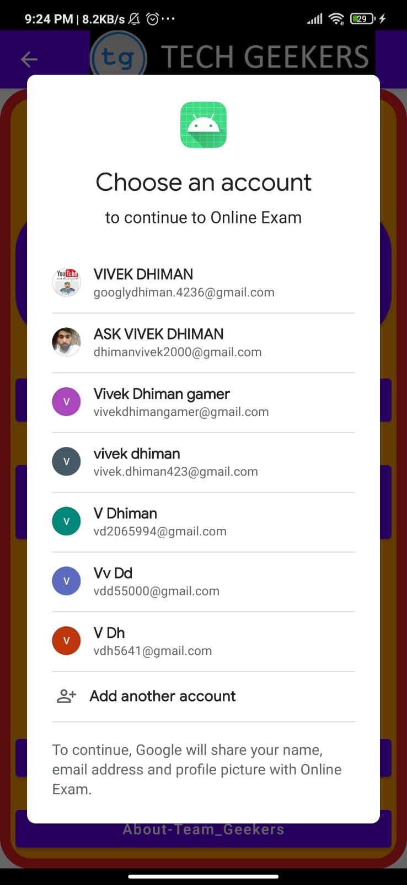 This is the Activity when we click on Google sign In Button (Here is the mails coming to select for sign in)

Coding Part For the Same + **Google Sign In** Integration is:-

**MAINACTIVITY.JAVA :-**

**package** com.example.onlineexam;  
  
**import** androidx.annotation.NonNull;  
**import** androidx.annotation.Nullable;  
**import** androidx.appcompat.app.ActionBar;  
**import** androidx.appcompat.app.AppCompatActivity;  
**import** androidx.cardview.widget.CardView;  
  
**import** android.bluetooth.BluetoothAdapter;  
**import** android.content.Intent;  
**import** android.net.ConnectivityManager;  
**import** android.net.NetworkInfo;  
**import** android.net.wifi.WifiManager;  
**import** android.os.Bundle;  
**import** android.util.Log;  
**import** android.view.Menu;  
**import** android.view.MenuItem;  
**import** android.view.View;  
**import** android.widget.Button;  
**import** android.widget.Toast;  
  
**import** com.google.android.gms.auth.api.signin.GoogleSignIn;  
**import** com.google.android.gms.auth.api.signin.GoogleSignInAccount;  
**import** com.google.android.gms.auth.api.signin.GoogleSignInClient;  
**import** com.google.android.gms.auth.api.signin.GoogleSignInOptions;  
**import** com.google.android.gms.common.SignInButton;  
**import** com.google.android.gms.common.api.ApiException;  
**import** com.google.android.gms.tasks.Task;  
**import** com.google.android.material.snackbar.Snackbar;  
  
  
**public class** MainActivity **extends** AppCompatActivity **implements** View.OnClickListener {  
  
  
  
  
  
 SignInButton **google**;  
 GoogleSignInClient **mGoogleSignInClient**;  
 **int RC_SIGN_IN** = 0;  
  
 Button **web**,**wifi**,**gee**;  
 Button **btnn**,**block**;  
 BluetoothAdapter **ba**;  
 CardView **addGroup**,**addUpload**;  
  
  
  
  
  
 @Override  
 **protected void** onCreate(Bundle savedInstanceState) {  
 **super**.onCreate(savedInstanceState);  
 setContentView(R.layout.***activity_main***);  
  
  
 **addGroup** = findViewById(R.id.***addGroup***);  
 **addUpload** = findViewById(R.id.***addUpload***);  
 **gee** = findViewById(R.id.***gee***);  
  
 **block** = findViewById(R.id.***block***);  
 **addGroup**.setOnClickListener(**new** View.OnClickListener() {  
 @Override  
 **public void** onClick(View v) {  
Intent intent6 = **new** Intent(MainActivity.**this**,Teachers.**class**);  
startActivity(intent6);  
 }  
 });  
 getSupportActionBar().setDisplayShowHomeEnabled(**true**);  
 getSupportActionBar().setIcon(R.drawable.***geekers***);  
 getSupportActionBar().setTitle(**"Tech_Geekers"**);  
  
  
 **ba** = BluetoothAdapter.*getDefaultAdapter*();  
  
 ConnectivityManager cm;  
  
 getSupportActionBar().setDisplayHomeAsUpEnabled(**true**);  
  
 **block**.setOnClickListener(**new** View.OnClickListener() {  
 @Override  
 **public void** onClick(View v) {  
 Intent intent45 = **new** Intent(MainActivity.**this**,block_notification.**class**);  
 startActivity(intent45);  
 }  
 });  
  
 **gee**.setOnClickListener(**new** View.OnClickListener() {  
 @Override  
 **public void** onClick(View v) {  
  
Intent intent2222 = **new** Intent(MainActivity.**this**,ThirdActivity.**class**);  
startActivity(intent2222);  
  
 }  
 });  
  
  
  
  
**addUpload**.setOnClickListener(**new** View.OnClickListener() {  
 @Override  
 **public void** onClick(View v) {  
Intent intent11 = **new** Intent(MainActivity.**this**,cameraclick.**class**);  
startActivity(intent11);  
 }  
});  
  
  
 **web** = findViewById(R.id.***web***);  
 **btnn** = findViewById(R.id.***btnn***);  
  
 cm= (ConnectivityManager) getSystemService(***CONNECTIVITY_SERVICE***);  
  
 **wifi** =findViewById(R.id.***wifi***);  
 **wifi**.setOnClickListener(**new** View.OnClickListener() {  
 @Override  
 **public void** onClick(View v) {  
  
 NetworkInfo ni = cm.getActiveNetworkInfo();  
 **if**(ni!=**null**&&ni.isConnected()&&ni.isAvailable()){  
 Snackbar.*make*(v,**"internet is connected"**,Snackbar.***LENGTH_LONG***).show();  
  
  
  
 }  
 **else** Snackbar.*make*(v,**"internet is off (turn it On)"**,Snackbar.***LENGTH_LONG***).show();  
  
 }  
 });  
  
  
  
  
  
  
 **btnn**.setOnClickListener(**new** View.OnClickListener() {  
 @Override  
 **public void** onClick(View v) {  
 **if**(v==**btnn**){  
 **if**(**ba**.isEnabled())  
 Toast.*makeText*(MainActivity.**this**, **"Bluetooth is On (Turn It Off)"**, Toast.***LENGTH_SHORT***).show();  
 **else** Toast.*makeText*(MainActivity.**this**, **"Bluetooth is Off (GOOD)"**, Toast.***LENGTH_SHORT***).show();  
 }  
  
 }  
 });  
  
 **google** = findViewById(R.id.***google***);  
  
 **google**.setOnClickListener(**new** View.OnClickListener() {  
 @Override  
 **public void** onClick(View v) {  
 **switch** (v.getId()) {  
 **case** R.id.***google***:  
 signIn();  
 **break**;  
 }  
 }  
 });  
  
 **web**.setOnClickListener(**new** View.OnClickListener() {  
 @Override  
 **public void** onClick(View v) {  
 Intent intentt = **new** Intent(MainActivity.**this**,webpage.**class**);  
 startActivity(intentt);  
 }  
 });  
  
  
  
  
 GoogleSignInOptions gso = **new** GoogleSignInOptions.Builder(GoogleSignInOptions.***DEFAULT_SIGN_IN***)  
 .requestEmail()  
 .build();  
  
 **mGoogleSignInClient** = GoogleSignIn.*getClient*(**this**, gso);  
 }  
  
  
 **private void** signIn() {  
 Intent signInIntent = **mGoogleSignInClient**.getSignInIntent();  
 startActivityForResult(signInIntent, **RC_SIGN_IN**);  
 }  
 @Override  
 **public void** onActivityResult(**int** requestCode, **int** resultCode, Intent data) {  
 **super**.onActivityResult(requestCode, resultCode, data);  
  
 *// Result returned from launching the Intent from GoogleSignInClient.getSignInIntent(...);* **if** (requestCode == **RC_SIGN_IN**) {  
 *// The Task returned from this call is always completed, no need to attach  
 // a listener.* Task<GoogleSignInAccount> task = GoogleSignIn.*getSignedInAccountFromIntent*(data);  
 handleSignInResult(task);  
 }  
 }  
  
 **private void** handleSignInResult(Task<GoogleSignInAccount> completedTask) {  
 **try** {  
 GoogleSignInAccount account = completedTask.getResult(ApiException.**class**);  
  
 *// Signed in successfully, show authenticated UI.* Intent intent = **new** Intent(MainActivity.**this**,SecondActivity.**class**);  
  
 startActivity(intent);  
 } **catch** (ApiException e) {  
 *// The ApiException status code indicates the detailed failure reason.  
 // Please refer to the GoogleSignInStatusCodes class reference for more information.* Log.*w*( **"Error"**, **"signInResult:failed code="** + e.getStatusCode());  
  
 }  
 }  
  
 @Override  
 **public boolean** onOptionsItemSelected(@NonNull MenuItem item) {  
 **if**(item.getItemId()==android.R.id.***home***)  
 onBackPressed();  
 **return super**.onOptionsItemSelected(item);  
  
  
 }  
  
  
  
  
 @Override  
 **public void** onClick(View v) {  
  
 }  
}

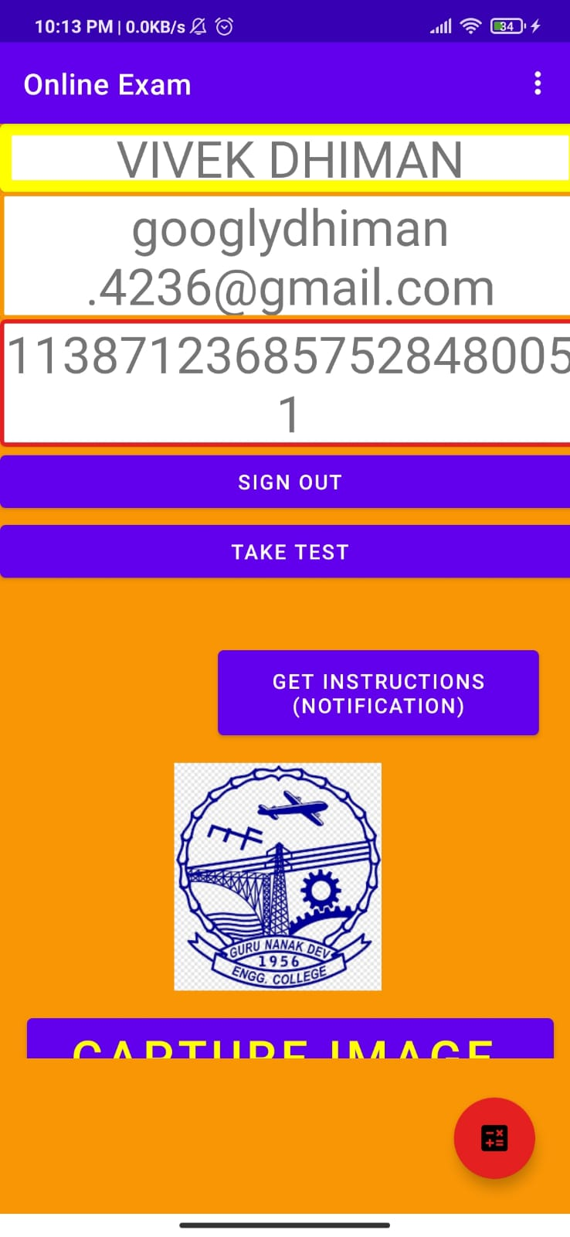

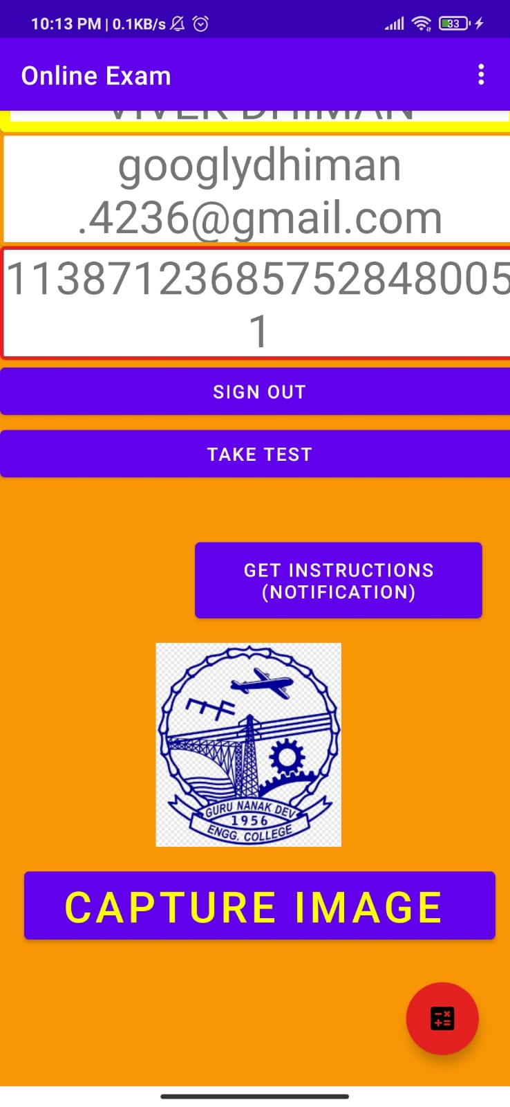 After sign in we came to this activity as shown in pics above.

This app activity covers :-

* 1. User name
  2. User email
  3. User id or roll no.
  4. Sign out button
  5. Get instructions notification
  6. Capture or upload image to get started for the exam
  7. We also add calculator for students

Now coding part for the same is :-

ACTIVITY_SECOND.XML

<**RelativeLayout xmlns:tools="http://schemas.android.com/tools"  
 android:layout_height="match_parent"  
 android:layout_width="match_parent"  
  
 android:orientation="vertical"  
  
 android:background="@color/orange"  
  
  
  
 xmlns:android="http://schemas.android.com/apk/res/android"  
 xmlns:app="http://schemas.android.com/apk/res-auto"**>  
  
  
 <**ScrollView  
 android:layout_width="match_parent"  
 android:layout_height="643dp"**>  
  
 <**LinearLayout  
 android:layout_width="400dp"  
 android:layout_height="667dp"  
 android:orientation="vertical"  
 tools:context=".SecondActivity"**>  
  
  
 <**com.google.android.material.card.MaterialCardView  
  
 android:layout_width="match_parent"  
 android:layout_height="wrap_content"  
  
 app:strokeColor="@color/yellow"  
 app:strokeWidth="8dp"**>  
  
 <**TextView  
 android:id="@+id/name"  
 android:layout_width="match_parent"  
 android:layout_height="wrap_content"  
 android:gravity="center"  
 android:text="Name"  
 android:textSize="35sp"  
 tools:layout_editor_absoluteX="-16dp"  
 tools:layout_editor_absoluteY="377dp"** />  
 </**com.google.android.material.card.MaterialCardView**>  
  
 <**com.google.android.material.card.MaterialCardView  
  
 android:layout_width="match_parent"  
 android:layout_height="wrap_content"  
  
 app:strokeColor="@color/orange"  
 app:strokeWidth="3dp"**>  
  
 <**TextView  
 android:id="@+id/email"  
 android:layout_width="match_parent"  
 android:layout_height="wrap_content"  
 android:gravity="center"  
 android:text="Email id"  
 android:textSize="35sp"  
 tools:layout_editor_absoluteX="0dp"  
 tools:layout_editor_absoluteY="255dp"** />  
 </**com.google.android.material.card.MaterialCardView**>  
  
 <**com.google.android.material.card.MaterialCardView  
  
 android:layout_width="match_parent"  
 android:layout_height="wrap_content"  
  
 app:strokeColor="@color/red"  
 app:strokeWidth="3dp"**>  
  
 <**TextView  
 android:id="@+id/id"  
 android:layout_width="match_parent"  
 android:layout_height="wrap_content"  
 android:gravity="center"  
 android:text="id"  
 android:textSize="35sp"  
 tools:layout_editor_absoluteX="16dp"  
 tools:layout_editor_absoluteY="111dp"** />  
 </**com.google.android.material.card.MaterialCardView**>  
  
  
 <**Button  
 android:id="@+id/sign_out"  
 android:layout_width="match_parent"  
 android:layout_height="wrap_content"  
 android:text="sign out"  
 tools:layout_editor_absoluteX="-16dp"  
 tools:layout_editor_absoluteY="560dp"** />  
  
 <**Button  
 android:layout_width="match_parent"  
 android:layout_height="wrap_content"  
 android:text="take test"  
 android:id="@+id/tt"**/>  
  
 <**Button  
 android:id="@+id/g"  
 android:layout_width="221dp"  
 android:layout_height="70dp"  
 android:layout_marginLeft="150dp"  
 android:layout_marginTop="38dp"  
 android:gravity="center"  
 android:text="Get Instructions (Notification)"** />  
  
 <**ImageView  
 android:id="@+id/uu"  
 android:layout_width="143dp"  
 android:layout_height="183dp"  
 android:layout_marginLeft="120dp"  
 android:src="@drawable/download"** />  
  
 <**Button  
 android:id="@+id/CAMM"  
 android:layout_width="363dp"  
 android:layout_height="wrap_content"  
 android:layout_gravity="center"  
 android:gravity="center"  
 android:text="Capture image "  
  
 android:textColor="@color/yellow"  
 android:textSize="33sp"** />  
  
  
 </**LinearLayout**>  
  
 </**ScrollView**>  
  
  
 <**com.google.android.material.floatingactionbutton.FloatingActionButton  
 android:layout_width="wrap_content"  
 android:layout_alignParentBottom="true"  
 android:layout_alignParentRight="true"  
 android:layout_alignParentEnd="true"  
 android:layout_margin="24dp"  
 android:src="@drawable/ic_baseline_calculate_24"  
 app:backgroundTint="@color/red"  
 android:id="@+id/cal"  
 android:layout_height="wrap_content"** >  
  
  
 </**com.google.android.material.floatingactionbutton.FloatingActionButton**>  
  
 <**LinearLayout  
 android:layout_width="match_parent"  
 android:layout_height="wrap_content"  
 android:orientation="vertical"**>  
  
  
 </**LinearLayout**>  
  
  
  
</**RelativeLayout**>

Now let me show you how I make my app :-

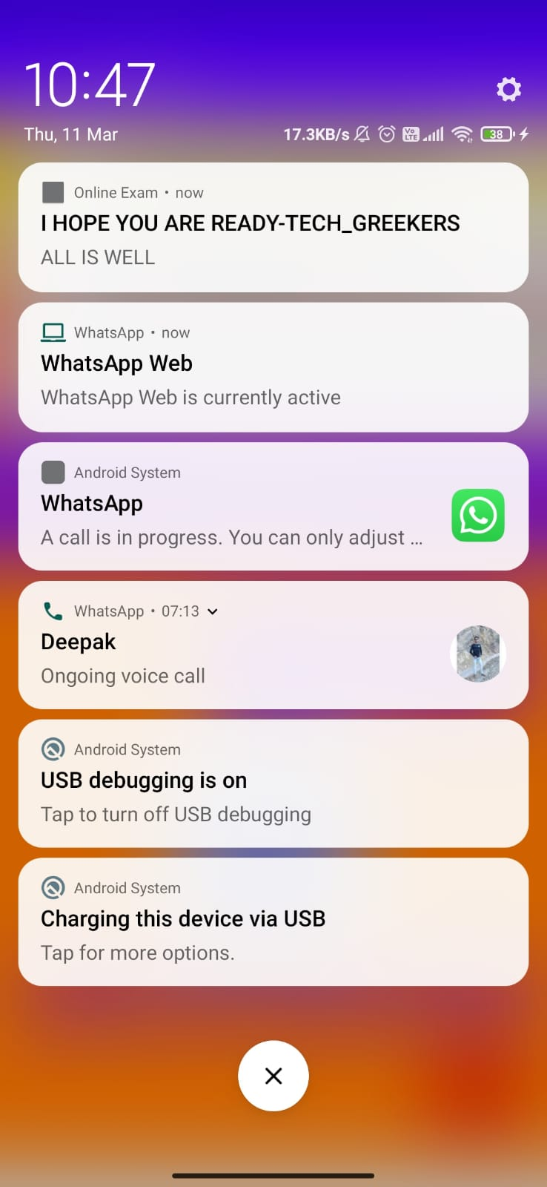 WHEN I CLICK ON NOTIFICATION THIS **MOBILE NOTIFICATION OCCURS–**

**I HOPE YOU ARE READY – TECH_GREEKERS**

**ALL IS WELL**

**Now User Click On Capture Image then this pop up Occurs –**

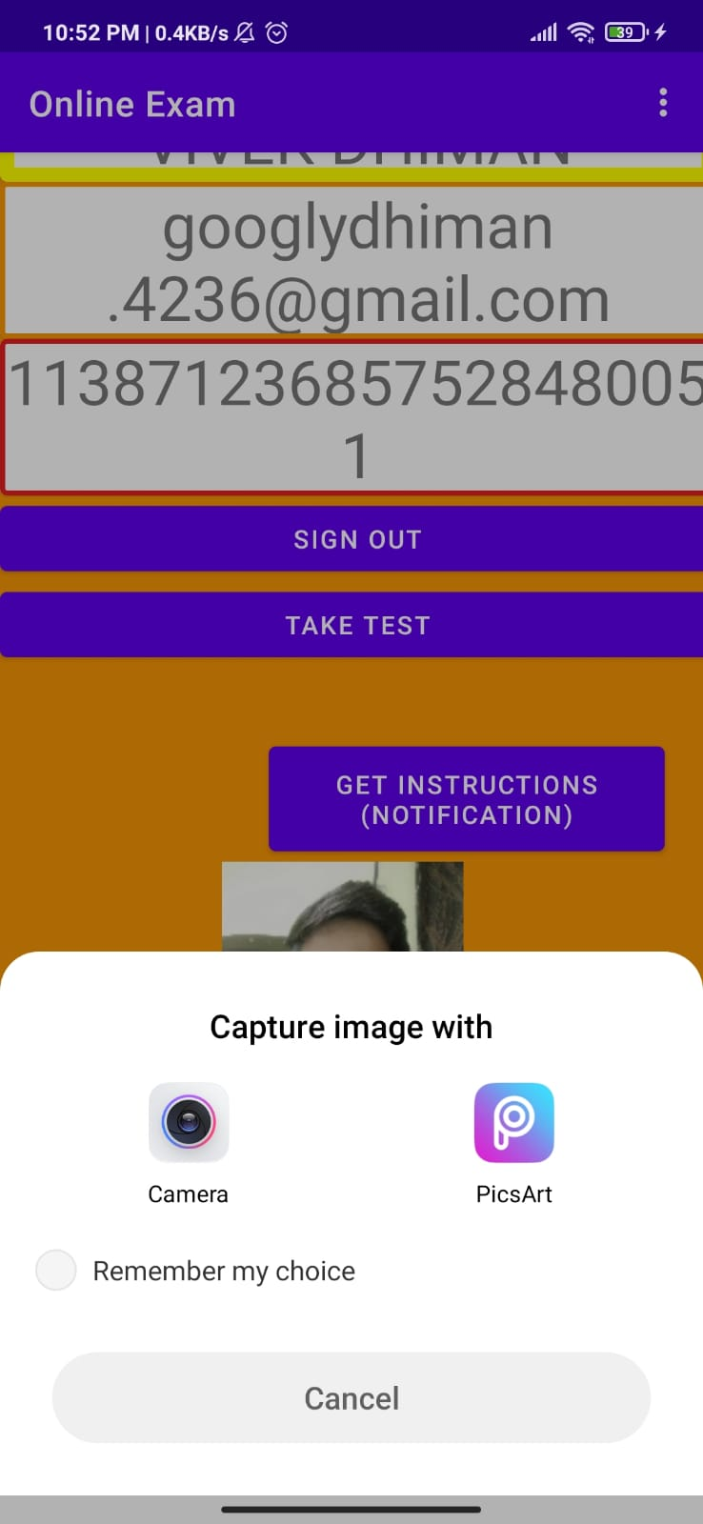 **user may have to click image and then click on tick button**

**Then this interface occurs –**

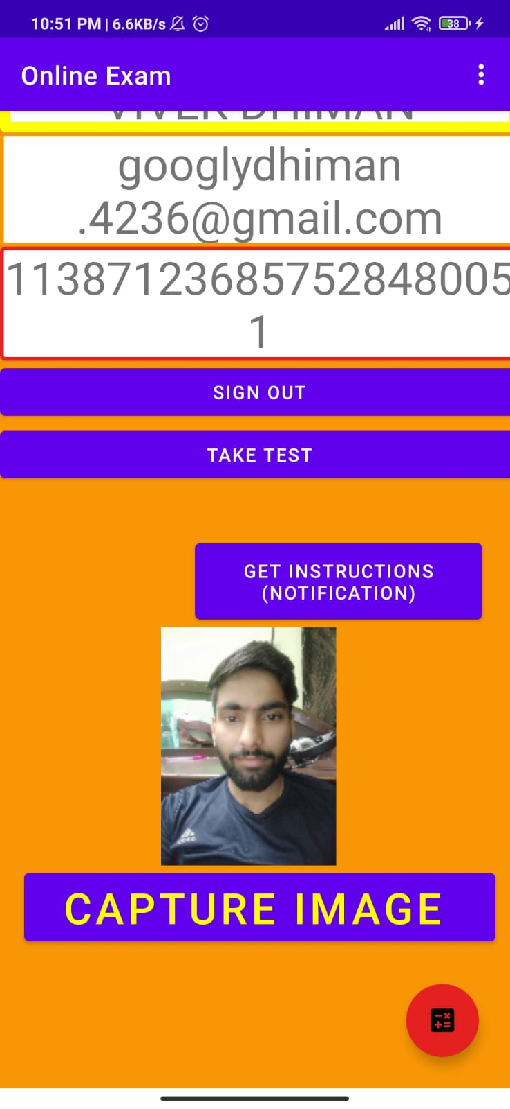 **here is my pic have been saved and I am ready to take test**

**When I click on take test then this interface occurs –**

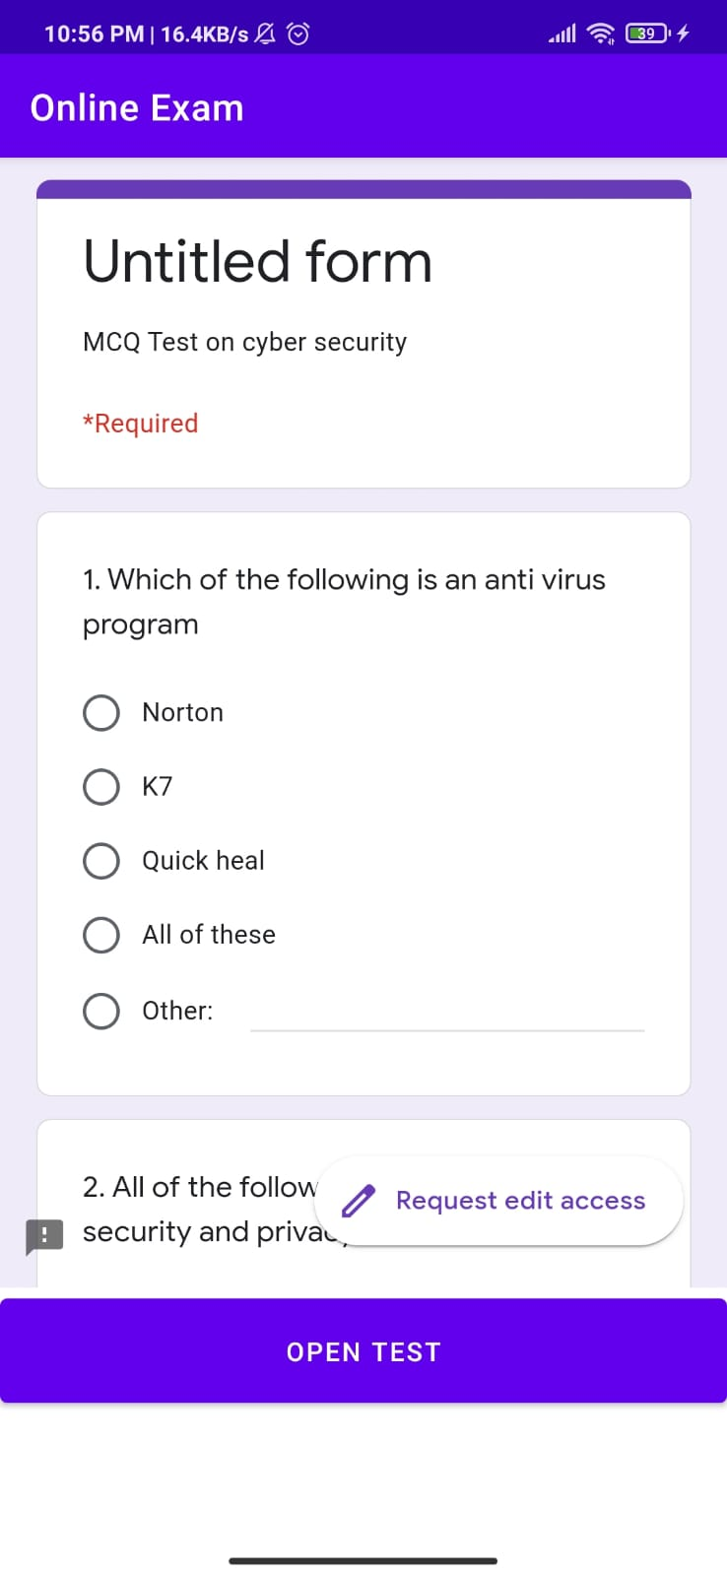 **here is the test and user not came out of the test either he or she may try to click back key of his or her mobile.**

**We have updated test portion by adding Calculator** in it –

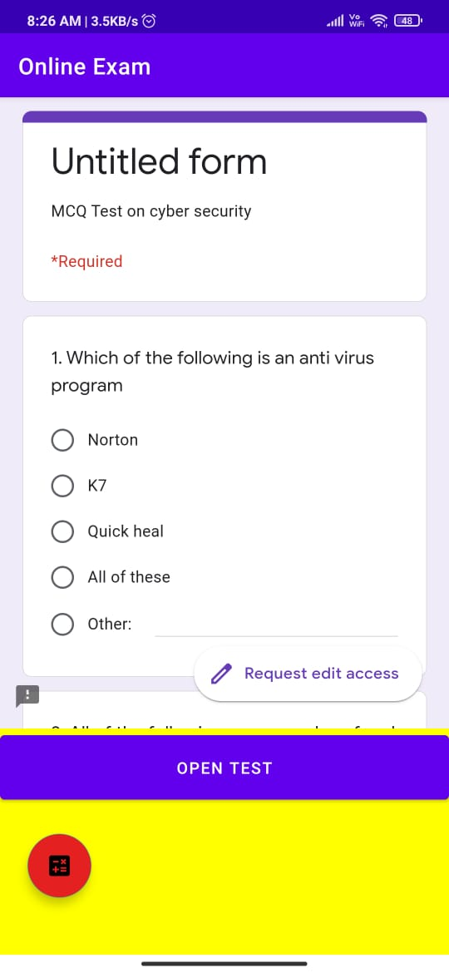

**Now when I click on calculator icon then this screen came out-**

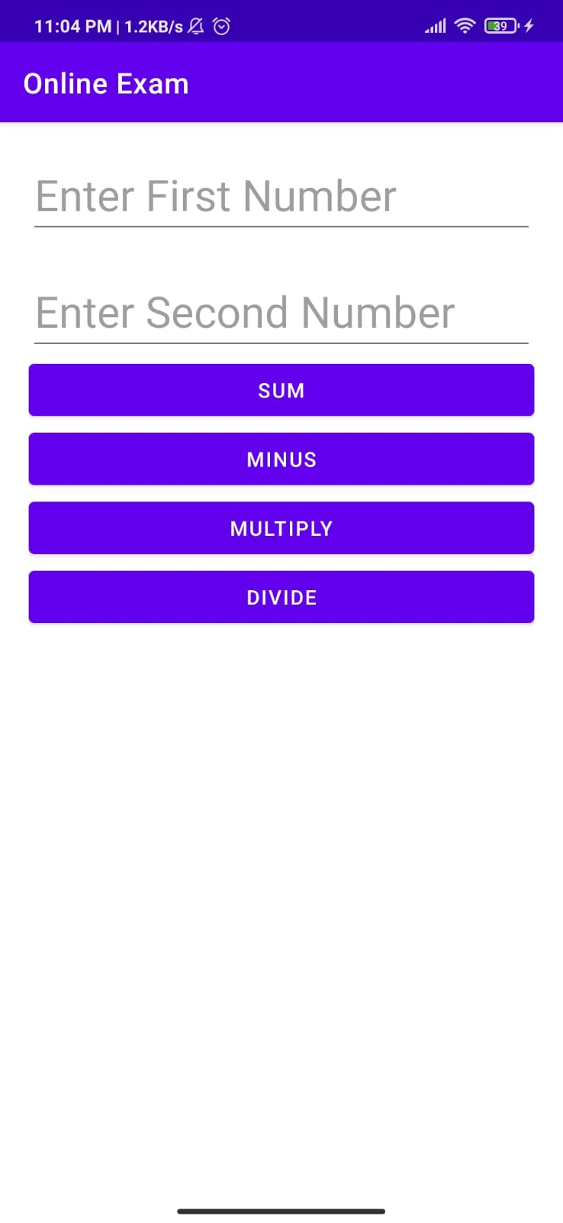 **here user may ADD , SUB. , MUL. And DIV.**

**We Have also added TEACHERS PORTAL to Upload Question Papers**

**-**

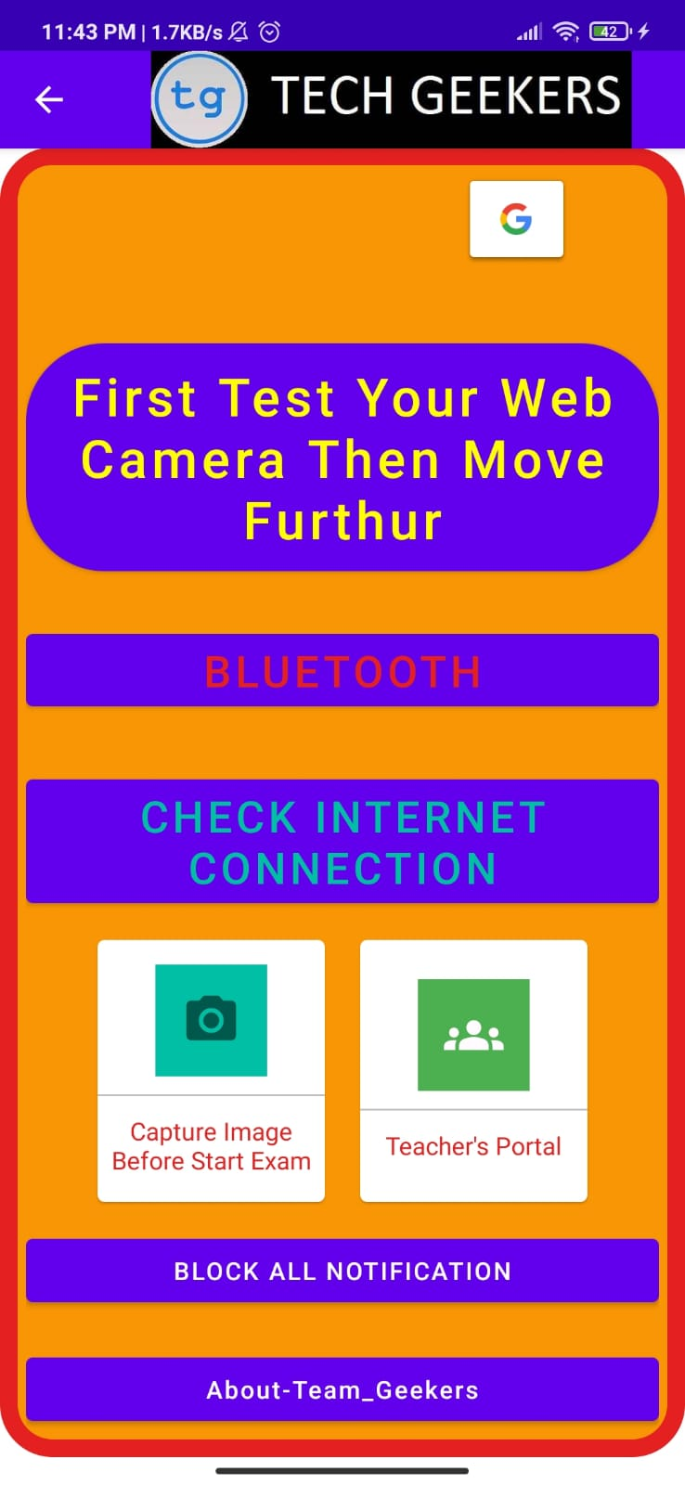

**When Teacher click on TEACHER’S PORTAL as shown Button above then this activity occurs –**

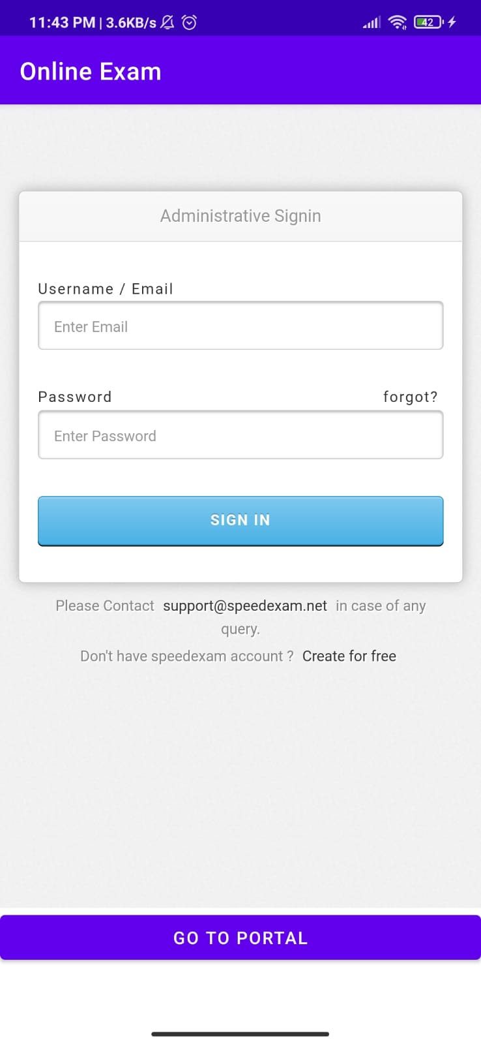**here Sign in and then upload or create Question Papers Or Attendance Part**

**NOW LET ME EXPLAIN BREEFLY ABOUT MY PROJECT –**

**My application follow all the requirement needed by HACKATHON 1.1**

**My applications gives application a new unique user friendly look which is must for all the developer to execute in their application.**

**Here is my apk link –**

<https://drive.google.com/file/d/19_uxUSmhyxo6lXiRCxsPbXVTVH6g_H9c/view>

**this link is of my google drive I have uploaded apk there**

**now here is my full apk source code if you want to run or install apk through ANDROID STUDIO**

**and PDF of this Project**

* + [**https://drive.google.com/file/d/19me7HeJn5EDN8ZM3rijYkih7ekyQIsNg/view**](https://drive.google.com/file/d/19me7HeJn5EDN8ZM3rijYkih7ekyQIsNg/view)

**Thankyou for conducting Hackathon 1.1**